## Full Name Generator v1

1. Create a .NET Console application.
2. Read first name, middle name, and last name values from console.
3. Generate and display full name on console in the following pattern.

**Pattern: {first name} {middle name} {last name}**

**Ex: Subhas Chandra Bose**

## Full Name Generator v2

1. V1 functionality + below validation rules.
2. First name, Last name are mandatory and Middle name is optional.
3. First name, Middle name, Last name must contain at least three characters.

## Sum of two numbers

1. Create a console app to read two numbers from console.
2. Numbers must be valid integers.
3. Calculate and print the sum of two numbers entered on to the console.

## Times Table

1. Create a console app to read a number from console.
2. Number must be valid integer.
3. Print Times table of entered number as below.

## Simple Calculator

1. Create a console app to read two numbers and Operator (+, -, *, /) from console.
2. Validate numbers and operator entered.
3. Calculate and print the result of values and operator entered.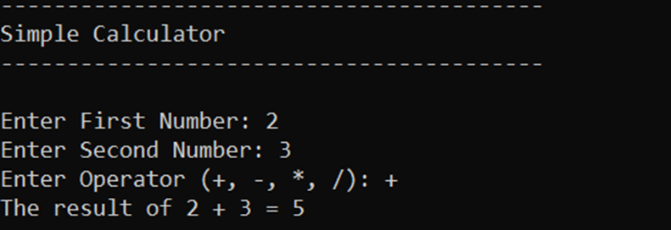

## Print Even and Odd Numbers from a range.

1. Create a console app to read Range start and end numbers from console.
2. Numbers must be valid integers.
3. Print the even numbers and odd number separately on to the console.

## Even Odd Number Checker

1. Create a console application to read a number from the console.
2. Check whether the entered number is a valid integer.
3. Check whether the entered number is an even or odd number.
4. Print the result as shown in the below figure.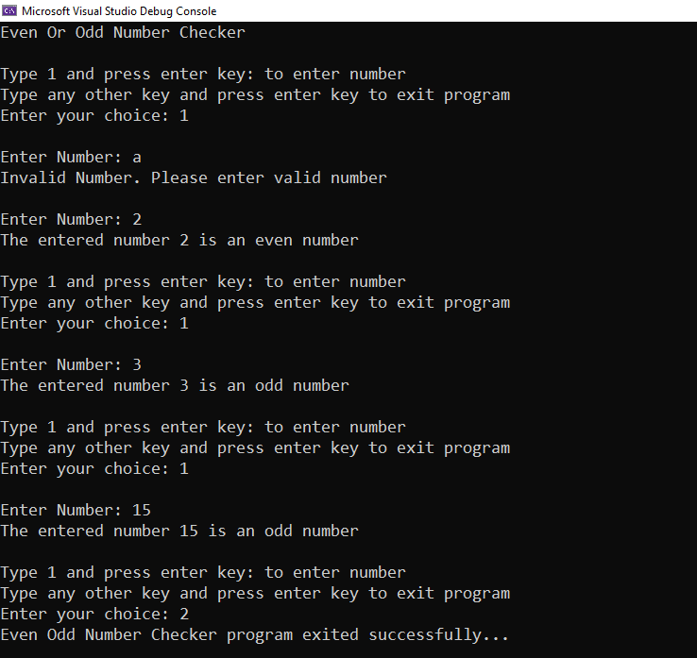

Contact App

Create a console application and implement below functionality.

1. Read first name, last name, phone number, and email address through console
2. Validate the entered contact details.
3. Search the contacts.
4. Add a new contact.
5. View the details of a contact.
6. Edit the details of a contact ( optional).
7. Delete a contact.
8. View a list of contact details.
9. Export all contacts to CSV file and print the exported path.

* 